Sakila Assignment **Queries**

1. What query would you run to get all the customers inside city_id = 312? Your query should return customer first name, last name, email, and address.

SELECT customer.first_name, customer.last_name, customer.email, address.address, address.address2

FROM customer

JOIN address ON customer.address_id = address.address_id

WHERE address.city_id = 312;



2. What query would you run to get all comedy films? Your query should return film title, description, release year, rating, special features, and genre (category).

SELECT film.title, film.description, film.release_year, film.rating, film.special_features, category.name

FROM film

JOIN film_category ON film.film_id = film_category.film_id

JOIN category ON film_category.category_id = category.category_id

WHERE category.name = 'Comedy';



3. What query would you run to get all the films joined by actor_id=5? Your query should return the actor id, actor name, film title, description, and release year.

SELECT actor.actor_id, actor.first_name, actor.last_name, film.title, film.description, film.release_year

FROM actor

JOIN film_actor ON actor.actor_id = film_actor.actor_id

JOIN film ON film_actor.film_id = film.film_id

WHERE actor.actor_id = 5;



4. What query would you run to get all the customers in store_id = 1 and inside these cities (1, 42, 312 and 459)? Your query should return customer first name, last name, email, and address.

SELECT customer.store_id, address.city_id, customer.first_name, customer.last_name, customer.email, address.address

FROM customer

JOIN address ON customer.address_id = address.address_id

WHERE customer.store_id = 1

AND address.city_id IN (1,42,312,459);

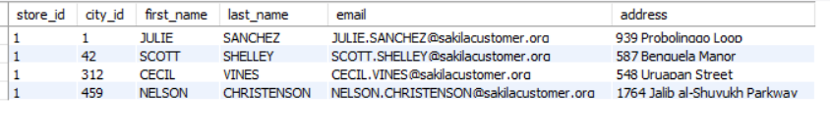

5. What query would you run to get all the films with a "rating = G" and "special feature = behind the scenes", joined by actor_id = 15? Your query should return the film title, description, release year, rating, and special feature. *Hint: You may use LIKE function in getting the 'behind the scenes' part.*

SELECT film.title, film.description, film.release_year, film.rating, film.special_features

FROM film

JOIN film_actor ON film.film_id = film_actor.film_id

WHERE film_actor.actor_id = 15

AND film.rating = 'G'

AND film.special_features LIKE '%behind the scenes%';



6. What query would you run to get all the actors that joined in the film_id = 369? Your query should return the film_id, title, actor_id, and actor_name.

SELECT film.film_id, film.title, actor.actor_id, actor.first_name, actor.last_name

FROM film

JOIN film_actor ON film.film_id = film_actor.film_id

JOIN actor ON film_actor.actor_id = actor.actor_id

WHERE film.film_id = 369;

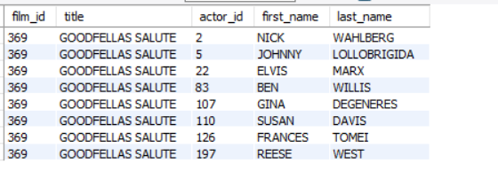

7. What query would you run to get all drama films with a rental rate of 2.99? Your query should return film title, description, release year, rating, special features, and genre (category).

SELECT film.film_id, film.title, film.description, film.release_year, film.rating, film.special_features, category.name AS genre, film.rental_rate

FROM film

JOIN film_category ON film.film_id = film_category.film_id

JOIN category ON category.category_id = film_category.category_id

WHERE film.rental_rate = 2.99

AND category.name = 'drama';



8. What query would you run to get all the action films which are joined by SANDRA KILMER? Your query should return film title, description, release year, rating, special features, genre (category), and actor's first name and last name.

SELECT actor.actor_id, actor.first_name, actor.last_name, film.title, film.description, film.rating, film.special_features, category.name AS genre

FROM actor

JOIN film_actor ON actor.actor_id = film_actor.actor_id

JOIN film ON film.film_id = film_actor.film_id

JOIN film_category ON film.film_id = film_category.film_id

JOIN category ON film_category.category_id = category.category_id

WHERE actor.first_name = 'SANDRA'

AND actor.last_name = 'KILMER'

AND category.name = 'action';

